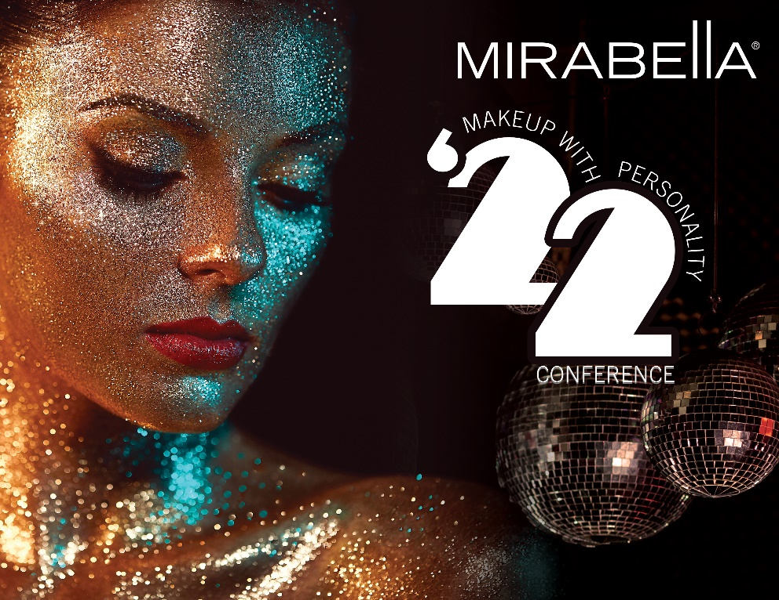
MAKEUP WITH PERSONALITY FALL ORDER FORM
September 18 – September 19, 2022
*Ticket to event must be paid in full by Aug 1st. Hotel reservations must be made by June 15th.

Name: |  | Package Selected:
Address: |  | City, State, Zip Code:
Phone Number: |  | Email:
Special Dietary Needs: |  | What is your key role at your location

STUDIO 54
Mirabella’s 2022 fifth annual Makeup with Personality Conference, cocktail party & Award Ceremony will be hosted in Kansas City’s newest and most beautiful hotels! Hotel Kansas City Historic Downtown Kansas City Hotel | Hotel Kansas City (hotelkc.com)! The evening will begin with a happy hour on the pool deck. A formal dinner will take place shortly after, with entertainment provided by the Ziggy and Neptunes and DJ. We will transform the hotel’s gorgeous stained glass ballroom back into the ’70s and dance the night away to our Studio 54 themed party!

MIRABELLA TRAINING package - $395.00

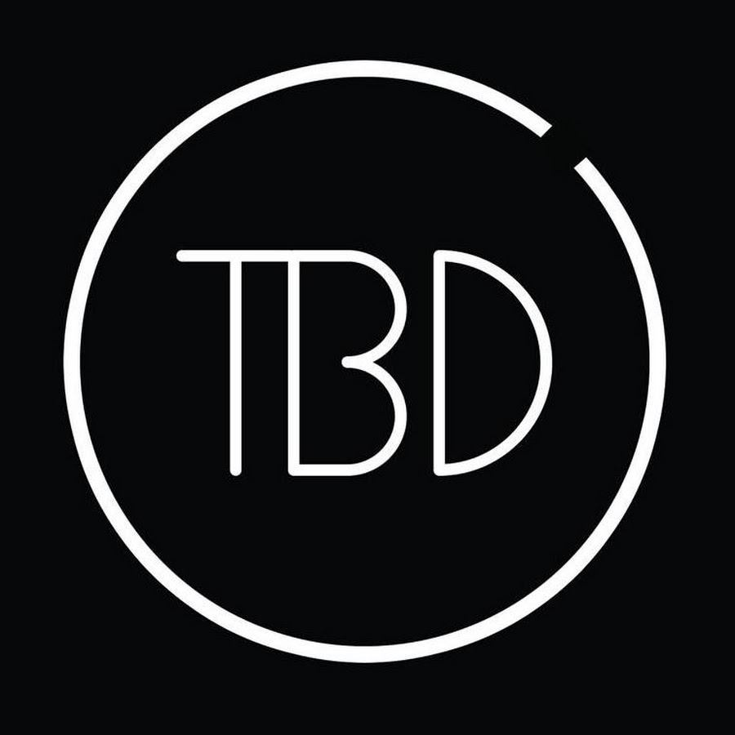
- Welcome lunch on Sunday
- Show off your Studio 54 themed attire at our themed award party Sunday night
- Targeted training Sunday – Monday based on your key role
- All the exciting NEW Mirabella items+ launching fall 2022! Valued at over $250

student/spouse package - $250.00
- Welcome lunch on Sunday
- Show off your Studio 54 themed attire at our themed award party Sunday night
- Targeted training Sunday – Monday based on your key role

Want to extend your stay in KC?
- We have negotiated a special room rate of $169.00 per night + taxes and parking for Sunday and Monday night. Anyone wishing to spend some additional time in Kansas City can use special negotiated rate of $199 + taxes and parking. *Rate can be used up to two days before and/or after the event.
- If you do wish to include additional days during your trip, please make sure to add these extra dates to your hotel reservation. (If you wish to stay Friday night or Tuesday night, please reach out to your rep and they will help reserve the rooms.

IMPORTANT: Tickets are non-refundable after Jun. 15, 2022. We understand that life happens; however, ticket refunds will be given in product ONLY. No cancellations will be granted after Sept. 10, 2022.
*Mirabella must hit minimum room block by June 15st. SUBJECT TO COVID GUIDELINES

