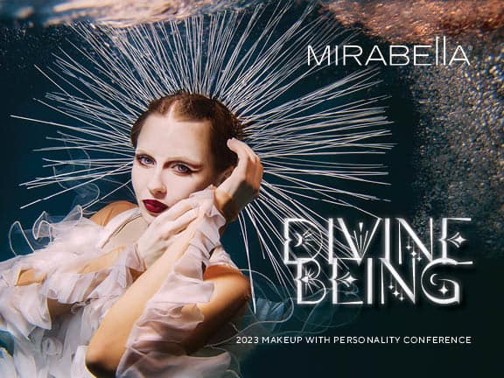
TRUE TO YOU BEAUTY - FALL ORDER FORM
OCTOBER 1ST-OCTOBER 2, 2023
*Ticket to event must be paid in full by Aug 15st. Hotel reservations must be made by August 15th 2023.

Name: |  | Package Selected:
Address: |  | City, State, Zip Code:
Phone Number: |  | Email:
Special Dietary Needs: |  | What is your key role at your location

DIVINE BEING
This year, the Mirabella Team invites you to spend the weekend immersing yourself in all things Mirabella. Bring your most creative self & join us as we pay homage to Mirabella’s “True to You” motto with this year’s theme: Divine Being.
Come one, come all you beautiful gods, goddesses, kings, queens, deities, and celestial spirits. Let’s make our 6th annual True to You Beauty Conference the best one yet!
Mirabella’s 2023 True to You Beauty Conference will take place at one of Kansas City’s most exquisite hotels within walking distance of the city’s Plaza district – the Fontaine Hotel. Learn more about this stunning hotel: https://www.thefontainehotel.com/
Our 6th annual education event will include two days of in-depth Mirabella product knowledge and technique training, and the highly anticipated themed cocktail party and awards ceremony. The themed celebration will begin with happy hour on the pool deck, followed by a formal dinner, a live performance by Ziggy & The Neptunes, DJ, and the awards ceremony. Get creative, #bellababes, as you show off your Divine Being interpretations! See our Save the Date Conference Brochure for more information and inspiration.

MIRABELLA TRAINING package - $395.00

- Welcome Lunch, Sunday
- Divine Being Cocktail Party & Awards Ceremony, Sunday night
- Targeted Training & Education, Sunday – Monday (based on your key role)
- All the exciting NEW Mirabella items+ launching Fall 2023! (valued at over $250)
- HUGE ANNOUNCEMENT AND PRODUCT REVEAL

student/ STYLIST/ spouse package - $250.00
- Welcome Lunch, Sunday
- Divine Being Cocktail Party & Awards Ceremony, Sunday night
- Targeted Training & Education, Sunday – Monday (based on your key role)

Want to extend your stay in KC?
- We have negotiated a special room rate of $169.00 per night (double, single, or quadruple occupancy) + taxes and parking for Sunday and Monday night. Anyone wishing to spend some additional time in Kansas City can use the special negotiated rate of $169 + taxes and parking. *Rate can be used up to two days before and/or after the event. MUST LET YOUR SALES REP KNOW IF YOU WOULD LIKE TO EXTEND! PLEASE NOTE THERE ARE A LIMITED NUMBER OF DOUBLE QUEEN BEDS, so book EARLY! Limited number of adjoining rooms!

IMPORTANT: Tickets are non-refundable after June 20, 2023. We understand that life happens; however, ticket refunds will be given in product ONLY. No cancellations will be granted after Sept. 10, 2023.
*Mirabella must hit minimum room block by July 1, 2023.

